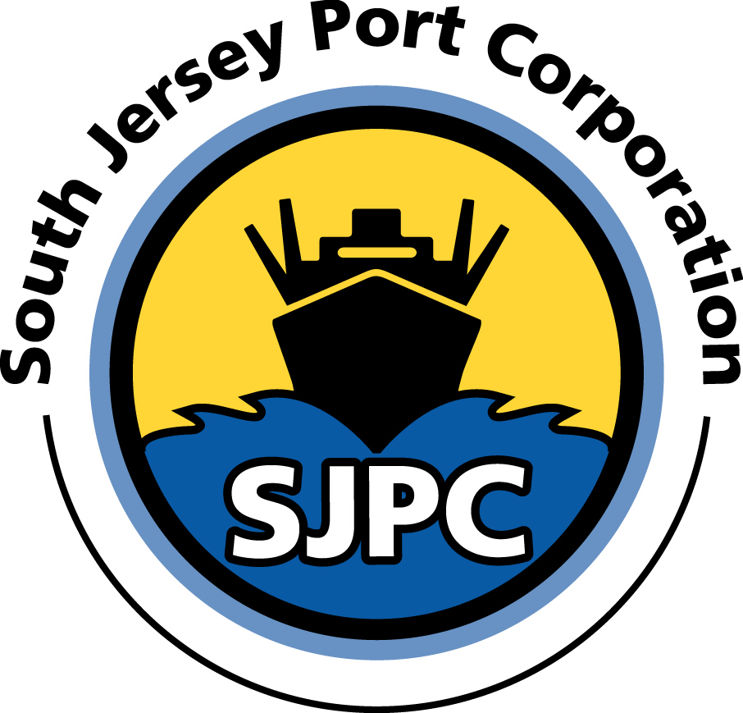
SOUTH JERSEY PORT CORPORATION
NOTICE OF JOB OPENING

OPERATIONS SUPERVISOR

In accordance with Article 9 and Article 13 of the Agreement between SJPC and CWA, Local 1040, employees are hereby notified that SJPC will accept applications for the position of OPERATIONS SUPERVISOR. The applicant will be required to directly supervise terminal activities and terminal labor related to the daily operations.

The successful applicant will receive an annual compensation of $66,028.36.

ESSENTIAL DUTIES AND RESPONSIBILITIES: Include the following. Refer to job description. Other duties may be assigned.

- Attends daily supervisor’s meetings to assist in planning the priority, volume and sequence of tasks assigned for the day.
- Maintains berth and storage areas to ensure optimum utilization of terminal facilities.
- Supervises and reviews the checking/counting operations to ensure accuracy of all cargo documentation.
- Examines the condition of cargo for clues of damage and prepares reports accordingly.
- Supervises truck loading and unloading to ensure cargo is handled safely and in an efficient manner.
- Consults with customers and terminal users to provide timely and responsive customer service.
- Documents and reports accidents, injuries, or other emergency situations directly to management for appropriate action.
- Appends storage lists, tallies, and time sheets for terminal employees on a daily basis or as required.
- Acts as the assistant terminal superintendent in their absence.
- Performs additional tasks as assigned.
JOB QUALIFICATIONS:
Candidate must meet the following qualifications:
- Must have a high school diploma or equivalent. Additional college or business school courses preferred.
- Requires the ability to plan and prioritize tasks relative to port operations and supervise labor.
- Prior experience with cargo handling equipment, loading/unloading techniques, and general marine terminal operations preferred.
- Strong customer service orientation demonstrated flexibility and ability to work as a member of a team.

The New Jersey First Act, effective September 1, 2001, established residency requirements for all state employees. The applicant shall have their primary residence in the State of New Jersey. The applicant must possess or be able to obtain a federal Transportation Worker Identification Credential issued by the Transportation Security Administration.

PROCEDURE:
Applicants interested in the position of OPERATIONS SUPERVISOR should submit an application to careers@southjerseyport.com, Human Resources.

