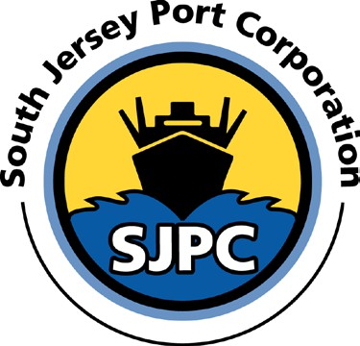

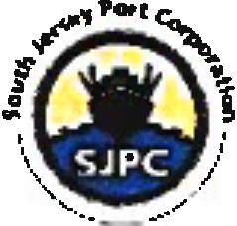
SOUTH JERSEY PORT CORPORATION NOTICE OF JOB OPENING
I
01/21/2025

MAINTENANCE REPAIRMAN (CARPENTER)

SUMMARY: In accordance with our most recent Union Agreement Article XIX, section 1, employees are hereby notified that the South Jersey Port Corporation will be accepting applications from employees for MAINTENANCE REPAIRMAN (CARPENTER). The successful applicant will perform maintenance functions at all South Jersey Port Corporation facilities. The success applicant will be paid in accordance with current labor contract as:

First 480 Hours After Appointment:

After 480 Hours Continuous Service In New Job Classification:
$34.53 per hour
Effective 7/01/2024

$34.83 per hour

Effective 07/01/2024
ESSENTIAL DUTIES AND RESPONSIBILITIES: include the following. Other duties may be assigned.
- Submit a daily worksheet to the supervisor at the end of each day.
- Prepare reports and keep needed records.
- Perform all types of facilities maintenance work, in addition to carpentry work as required.
- Must be willing to work at heights in and on buildings, structures, and cranes at SJPC facilities.
- Must follow all safety rules as required by SJPC.
- Make appropriate repairs and recommendations.
- Prepare and/or work from schematics, plans, blueprints, and specifications in accordance with accepted trade practices.
- Make time and material estimates.
- Inspect work in progress for defects, hazards or other unsafe conditions and notify supervisor of these conditions.
- Must be able to install, maintain, inspect, repair and service all types of building interior and exterior work including wood and metal framing, gypsum wallboard, trim, doors, and frames, taping and spackling, painting, and drop ceilings.
- Assumes other duties as assigned.

JOB OUALIFICA TIONS: Candidate must meet the following qualifications:
- Must have High School Diploma or equivalent, preferably completion of vocational school.
- Must be qualified and experience (minimum of 5 years) to perform journeyman level work or equivalent formal training in the carpentry field.
- Strong working knowledge of carpentry techniques and methods, including installation and construction.
- Proficient in using electrical and hand tools as well as measurement tools.
- Able to read and interpret blueprints and technical drawings.
- Strong problem solving and critical thinking skills.
- Good physical condition, stamina, and dexterity
- Must possess a federal Transportation Worker Identification Credential issued by the Transportation Security Administration.
- Must possess a valid, unrevoked, and unsuspended driver's license.
The New Jersey First Act, effective September l, 200 I, established residency requirements for all state employees. The applicant shall have their primary residence in the State of New Jersey.
TESTING: All applicants for this job opening must be willing to take a written test to demonstrate qualification in one or all the above areas of specialization. A practical test in these areas will also be required. Management will judge whether an applicant is qualified for this position. Certain portions of the examination procedure may be waived by Management based on an applicant's experience in performing this level of work.
WORK ENVIRONMENT: The work environment characteristics described here are representative of those an employee encounters while performing the essential functions of this job. Reasonable accommodations may be made to enable individuals with disabilities to perform the essential functions.

While performing the duties of this Job, the employee is occasionally exposed to wet and/or humid conditions and moving mechanical parts. The noise level in the work environment is usually moderate.
DISCLAIMER: This job description indicates in general the nature and levels of work, knowledge, skills, abilities, and other essential functions as covered under the Americans with Disabilities Act expected of an employee. It is not designed to cover or contain a comprehensive listing of activities, duties or responsibilities required of an employee. An employee may be asked to perform other duties as required.

Employees with disabilities must meet qualification standards that are job-related and consistent with business necessity and must be able to perform the "essential functions" of the position, with or without reasonable accommodation.

PROCEDURE: Applicants interested in the position of Maintenance Repairman (Carpenter) should submit a resume to jshaffer@southjerseyport.com.

_______________________________
Andrew Saporito Executive Director & CEO

